WS Color Subtraction II

6. In the diagrams below, several sheets of paper are illuminated by different primary colors of light (R for red, B for blue, and G for green). Indicate:

1. What color(s) of light will be ABSORBED; 2. What color(s) will be REFLECTED; 3. The appearance of the sheet of paper.

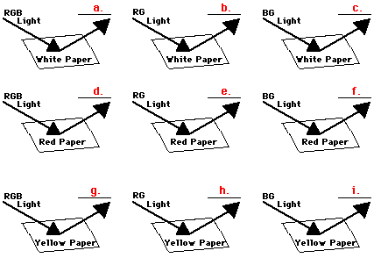

7. Different colored light sources shine on different colored sheets of paper. The indicated paper color represents the appearance of the paper when viewed in white light. Fill in the table below to show the color of light which reflects from the paper (i.e., the color observed).

|  |  |  |  |
| --- | --- | --- | --- |
|  | **Color of**  **Light** | **Color of**  **Paper** | **Color Observed** |
| a. | Red | Yellow | http://www.physicsclassroom.com/Class/images/spacer.gif |
| b. | Red | Magenta | http://www.physicsclassroom.com/Class/images/spacer.gif |
| c. | Blue | Blue | http://www.physicsclassroom.com/Class/images/spacer.gif |
| d. | Blue | Cyan | http://www.physicsclassroom.com/Class/images/spacer.gif |
| e. | Blue | Red | http://www.physicsclassroom.com/Class/images/spacer.gif |
| f. | Yellow | Red | http://www.physicsclassroom.com/Class/images/spacer.gif |
| g. | Yellow | Blue | http://www.physicsclassroom.com/Class/images/spacer.gif |

8. Suppose an object is permeated by a mixture of two or more paints and illuminated with white light. Fill in the table below to indicate the color appearance of the object (under white light).

|  |  |  |
| --- | --- | --- |
| **Paint**  **One** | **Paint**  **Two** | **Color Observed** |
| Cyan | Magenta | http://www.physicsclassroom.com/Class/images/spacer.gif |
| Magenta | Yellow | http://www.physicsclassroom.com/Class/images/spacer.gif |
| Cyan | Yellow | http://www.physicsclassroom.com/Class/images/spacer.gif |
| Cyan, Magenta & | Yellow | http://www.physicsclassroom.com/Class/images/spacer.gif |

9. Now repeat #8, but state the color that would be observed in colored light:

|  |  |
| --- | --- |
| **Paint**  **One** | **Paint Color Observed in Blue Light Color Observed in Red Light Color Observed in Green Light**  **Two** |
| Cyan | Magenta |
| Magenta | Yellow |
| Cyan | Yellow |
| Cyan, Magenta & | Yellow |